
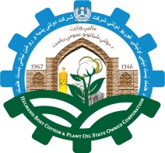

Islamic emirate of Afghanistan
Directorate general of emirates companies
Helmand bost cotton & vegetable oil Emirati owned corporation
Format information investment corporation
 | Company name | Bost Helmand cotton and vegetable oil emirate owned cot portion | 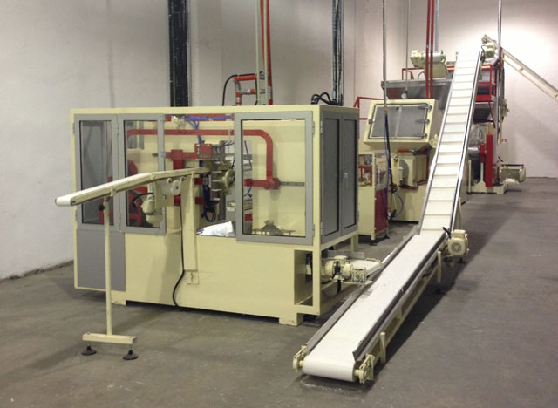
 | Address | Helmand Lashkar gha
 | Name project | Soap making machine | 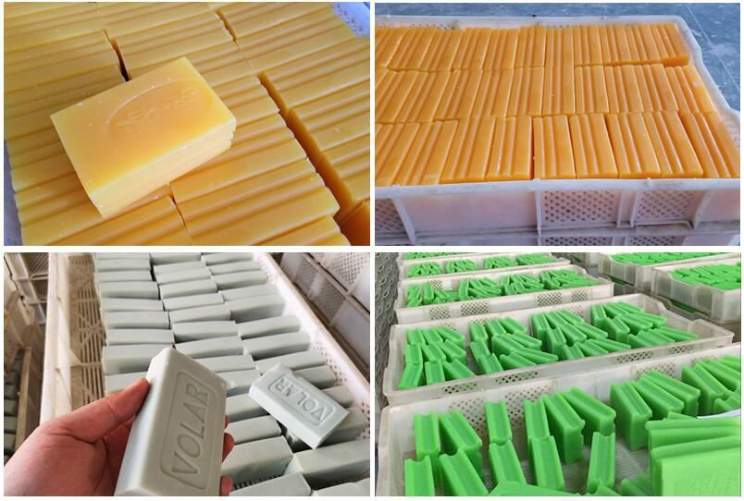
Contact time |  | One year contract
Estimated project costs |  | 100000$
Jop creation |  | Directly 25  Indirect 1500
Current budget |  | 0
Required budget |  | 100000$
Capacity |  | accordingtoproduction
Helmand bost corporation since 1346 which has active production and technical machinery and has a history of mechanical restoration of the system including a soap cutting machine that cuts soap materials in its original state and the mar ket demand for modern and contemporary soap with a modern label that attracts customers. The need to install modern machine that has a major role in the quality and quantity of soap pro ducts the company has many customers and at the same time the production is supplied to the market demand. and the company revenue increases.

Company administration

The machine of this company was install in 1346 it is a very old machine and its production consumption is high. at this Tim, the machines, necessary tools and other parts should be replaced.

2 investment opportunities in real estate
Fifty acres of land in Gershan district of de Helmand has been allocated for the construction of a textile factory.
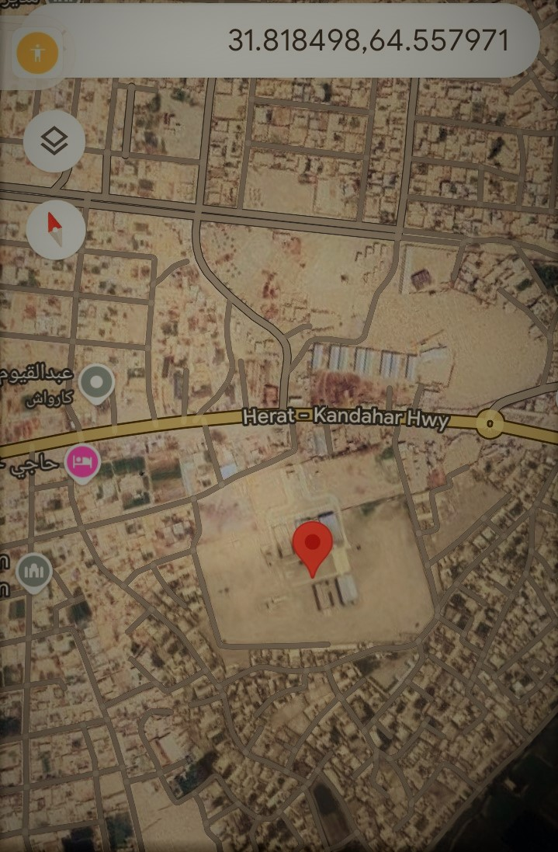
Form concept note
1 | Name department | Bost Helmand corporation
2 | Project name | Gershk textile factory with a capacity of 1000 tons of yarn with the final stage and 3,000,000 meters of pieces .
3
4 |  |  |  | Purpose  - Yarn production  - Piece production  - Production of cashmere cloth  Gps map mahal project
5
6
7 | Objectives | - Construction of a textile factory using raw materials (finished) by the state owned bost and factories company. private Helmand province  - The growth of the cotton industry and domestic production in  - The south – western region ofkishor. Interest (gender) and poverty reduction and effe chive security in the region  - Requirement market apparel, military units, civil administrations,  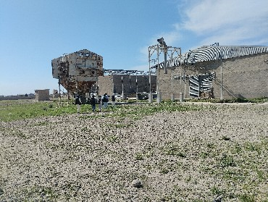  - And cotton market, cotton farmers cotton farming,  - Infrastructure investment wilbeprivate sector

Location | Helmand province  Distract Gurshak >city  Halaji grishk |  | 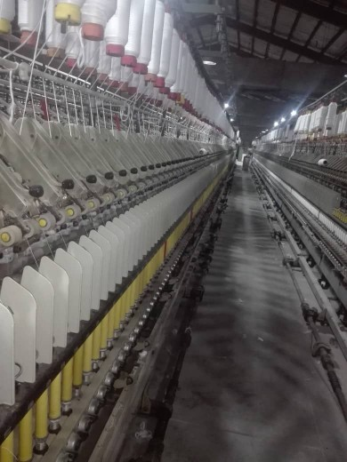
Tem project | The year / a yar/month10
The price of the total project will be in | 20million dollars
1select source finance | Budget development amount (1540) million Afghani.
Total beneficiaries |  |  | Beneficiary  The songs indirect
Beneficiaries directly | Male 9800 | Woman  6000 | male | woman |  |  | total
Total | 15800 |  | 800000 | 300000 |  |  | 1100000
Economic results
Ongoing implementation project | How many people will be employed full –time?  How many people wil be employed part –time?  After the project  How many people will be employed on a permanent full- time basis?  Howmanypeoplewil bemired on a part – time basis?  Number of total employment |  |  |  | Male200 | Woman 50 |  | Total250
Ongoing implementation project |  |  |  |  | Male500 | Woman100 |  | Total600
Ongoing implementation project |  |  |  |  | Male 400 | Woman 200 |  | Total 600
Ongoing implementation project |  |  |  |  | Male600 | Woman 200 |  | Total800
Ongoing implementation project |  |  |  |  | 1000 | 400 |  | Total1400

3description of the project brief
The construction of a textile factory is based on the programs of government agencies.

4How will the project addresses the needs of the community?
Nakh and taka clothing are the necessities of the life of the people of the society
The priority is the survival of human beings on earth if millions of people benefit from the construction of the said factory
It WI all be domestic and import will be reduced.

Implications of the proposed pro eject on common themes
Gender equality in employment
Capacity building workers in the field of product on
The impact is positive and direct on the environment
Evaluation of the positive cooperation of the regional council of the district
It is not necessary to use ground poppy cultivation material
Prevention of any kind of corruption
Lowering the level of unemployment and poverty in the region
Coordinating and attracting private sector capital.

With regards

3investment in property
14 acres of land. forty houses inGershak district. construction of (320residential houses) of 80 blocks in a standard manner
Name project | Gurshak halaji 40 family project |  | 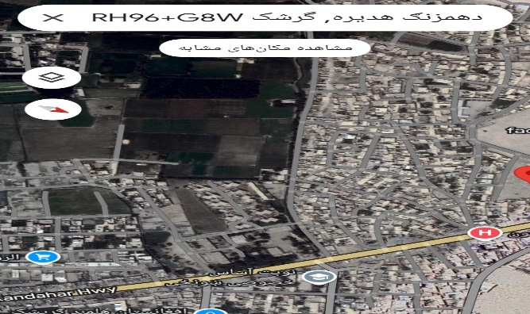
Address | District gurshak
Current situation | 10blocks containing 40 houses are close to demolition .
Required budget | 2million $
Contract | Construction of 80 blocks and 320 houses
Construction period | 18months
Type of contract | Ppp model
 |  | 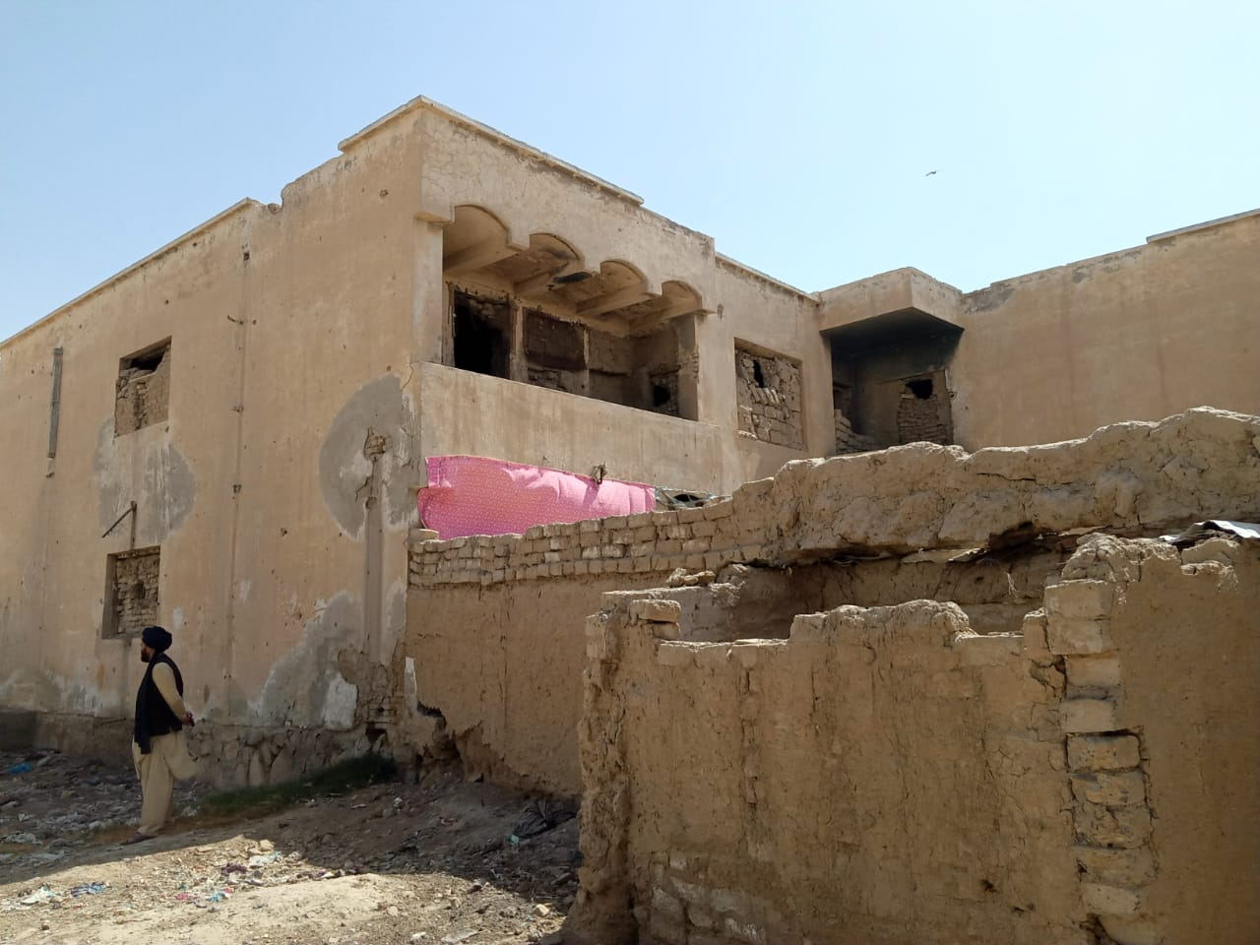

4 three warehouses of this factory , which are lo catted in the area of the old fort, have been built on 6 suitable area for investment .
three warehouses of this factory , which are lo catted in the area of the old fort, have been built on 6 suitable area for | 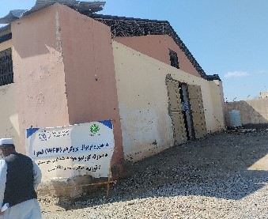 | 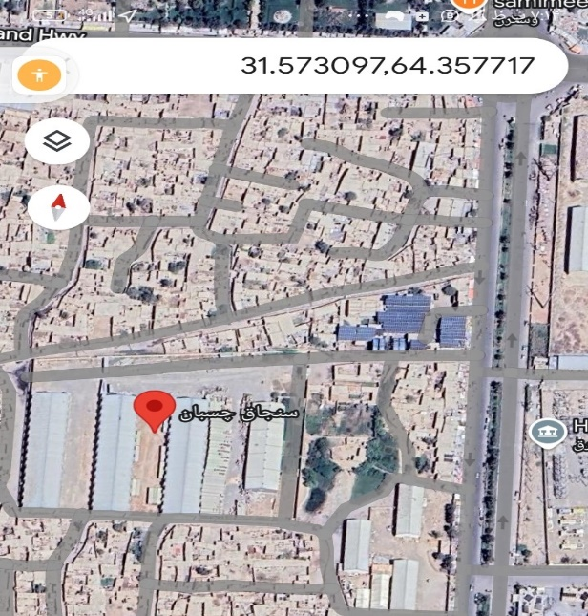
5 tow acres of land is located near d Helmand mania amandine. This is good area for investment. | 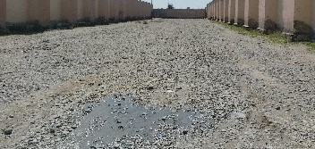 | 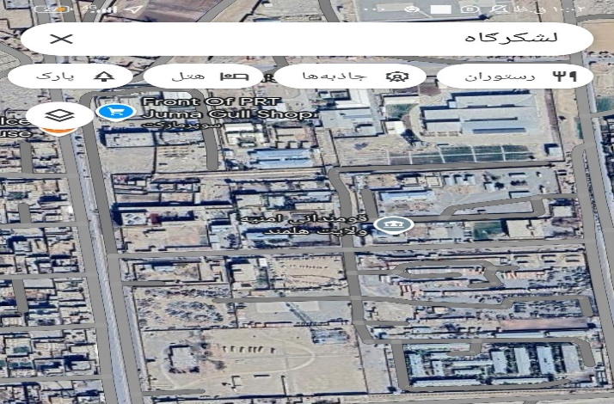
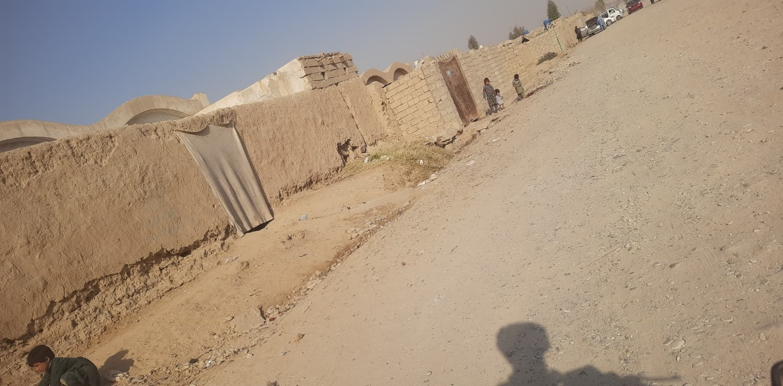  6 :20family houses of this company in the first district of d lashkargha ,it is 4acres of land .it is suitable place to build (80) blocks (320) houses . |  | 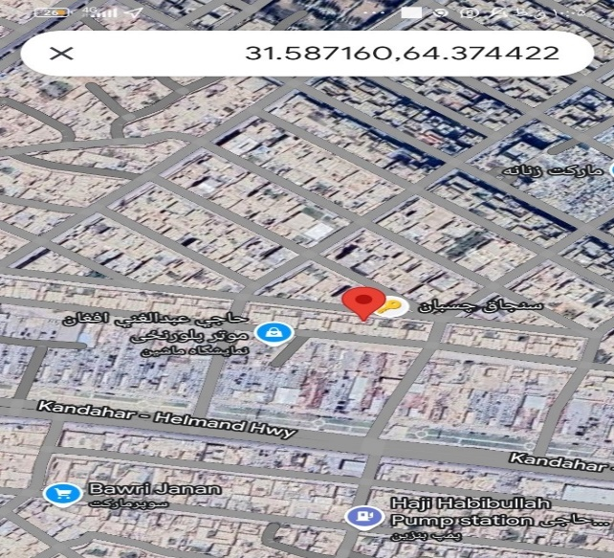
 |  | 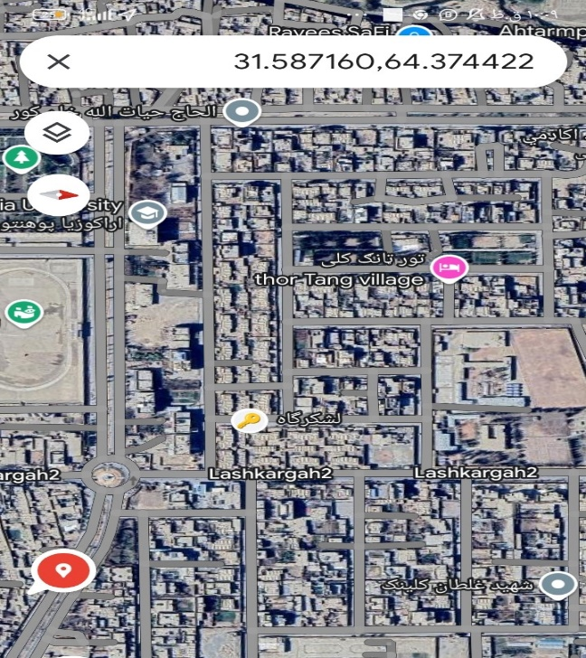
 | 42family houses with an area of 12 acres
  Name project | Gurshak halaji 40 family project
  Address | District gurshak
  Current situation | 10blocks containing 40 houses are close to demolition .
  Required budget | 2million $
  Contract | Construction of 80 blocks and 320 houses
  Construction period | 18months
  Type of contract | Ppp model
 | Lashkargha.
42family houses that are currently occupied by people are residential.
20million$
Construction of 80 blocks and 320 houses 18months
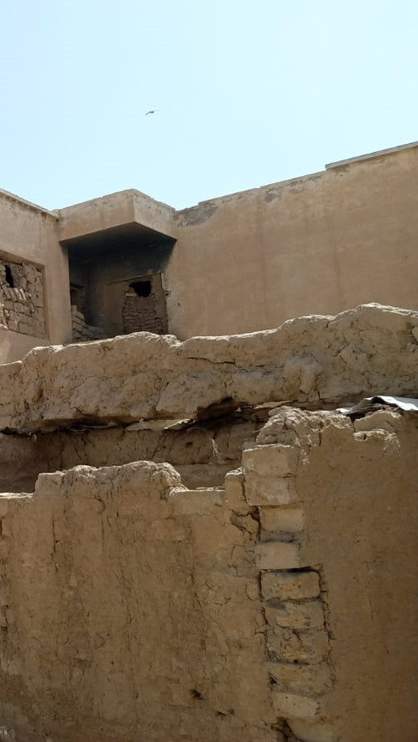
18months
Papp model

With regards

